Project 2.2 - Containerizing Microservices and Publishing Images to Registries

Task 1 - Prepare Microservices Application
Create or obtain a microservices-based application that includes multiple services such as:
- Frontend service
- ﻿﻿Backend service
- ﻿﻿Database service
Each service should exist in its own project directory.
#mkdir -p microservices-app/{frontend,backend,database}
#cd microservices-app

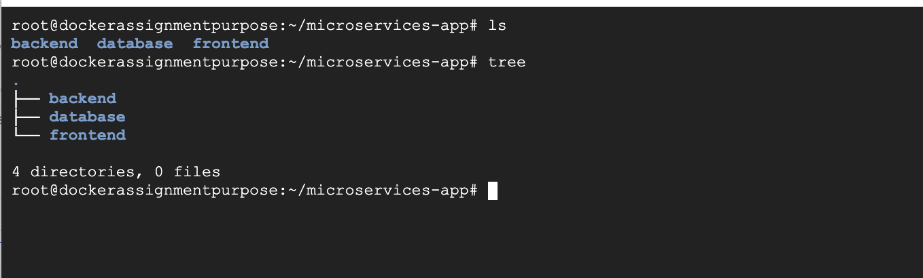

1.Let’s create backend service
Go to cd microservices-app/backend

Create main.go
#go run main.go
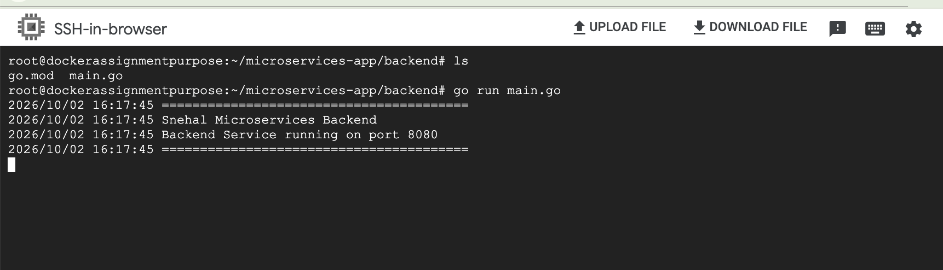
In Another terminal test it :
#curl http://localhost:8080
#curl http://localhost:8080/health
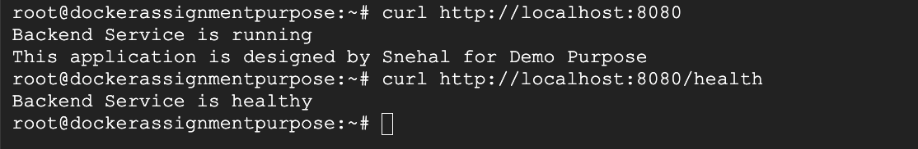

Now lets create frontend service :
#vi index.html

And for database :
For the database, we'll use PostgreSQL's official image.
We'll create a simple database Dockerfile.

2. Create the database secret
From your project directory:
cd ~/microservices-app

mkdir -p secrets

echo "snehal123" > secrets/db_password.txt
chmod 600 secrets/db_password.txt
You can use a stronger password for a real environment.

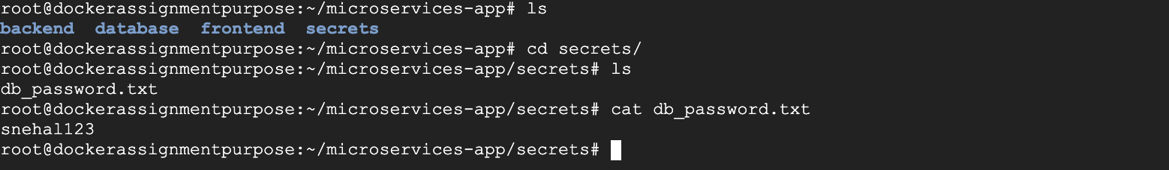

Now for our application we will use docker-compose to run.

Task 2 - Create Dockerfiles for Each Service
Write separate Dockerfiles for each microservice.
Each Dockerfile should define:
-﻿﻿The base image
-﻿﻿Application dependencies
-﻿﻿Application source code
-﻿﻿Startup configuration

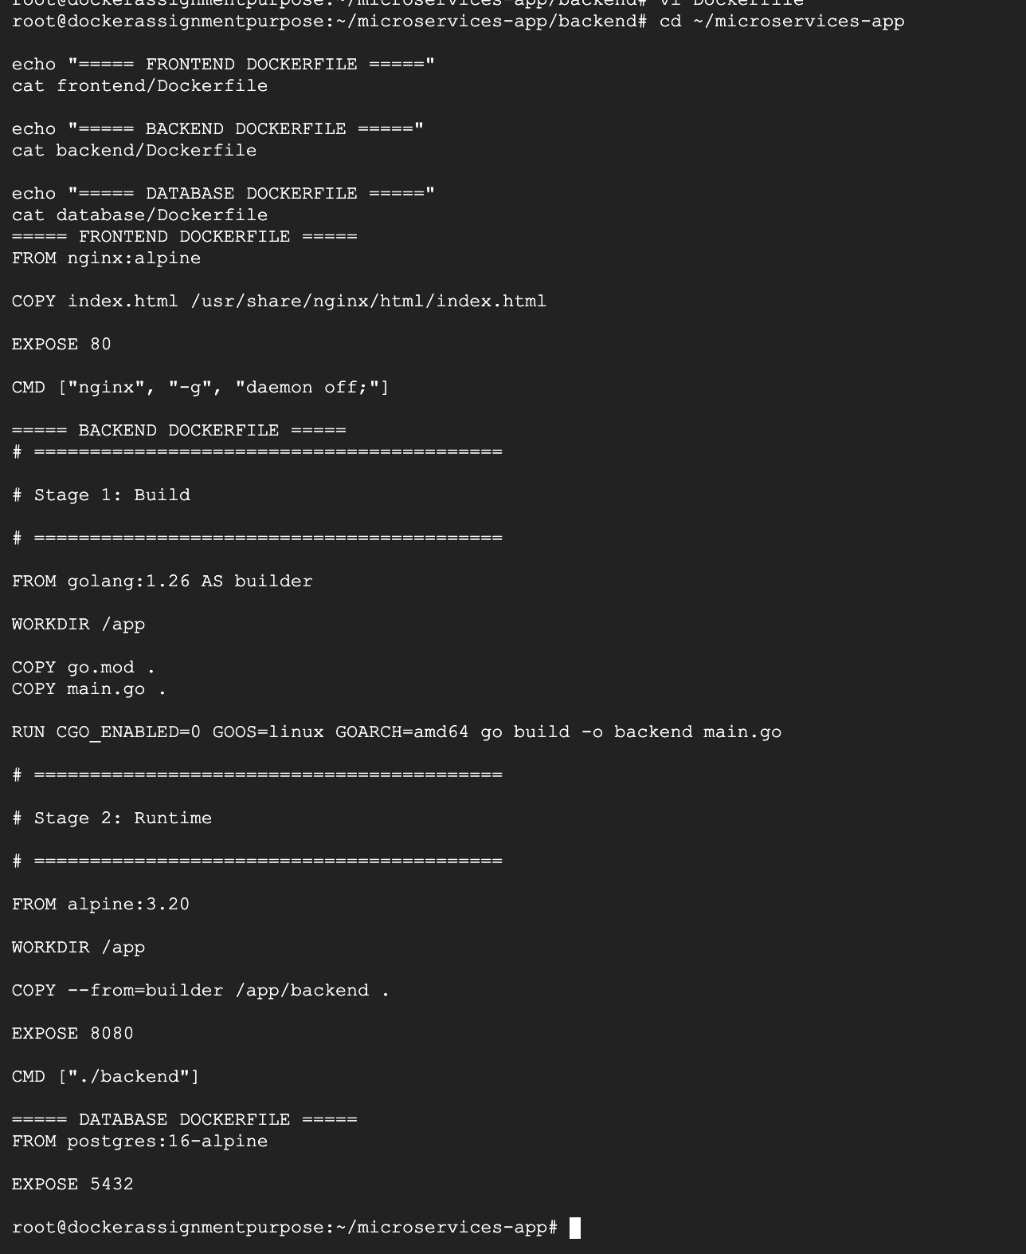

Task 3 - Build Docker Images
Build Docker images for all microservices.
Each service should produce a separate Docker image.
Ensure images are properly named and versioned.

Build Frontend image :
cd ~/microservices-app
docker build -t microservices-frontend:1.0 ./frontend

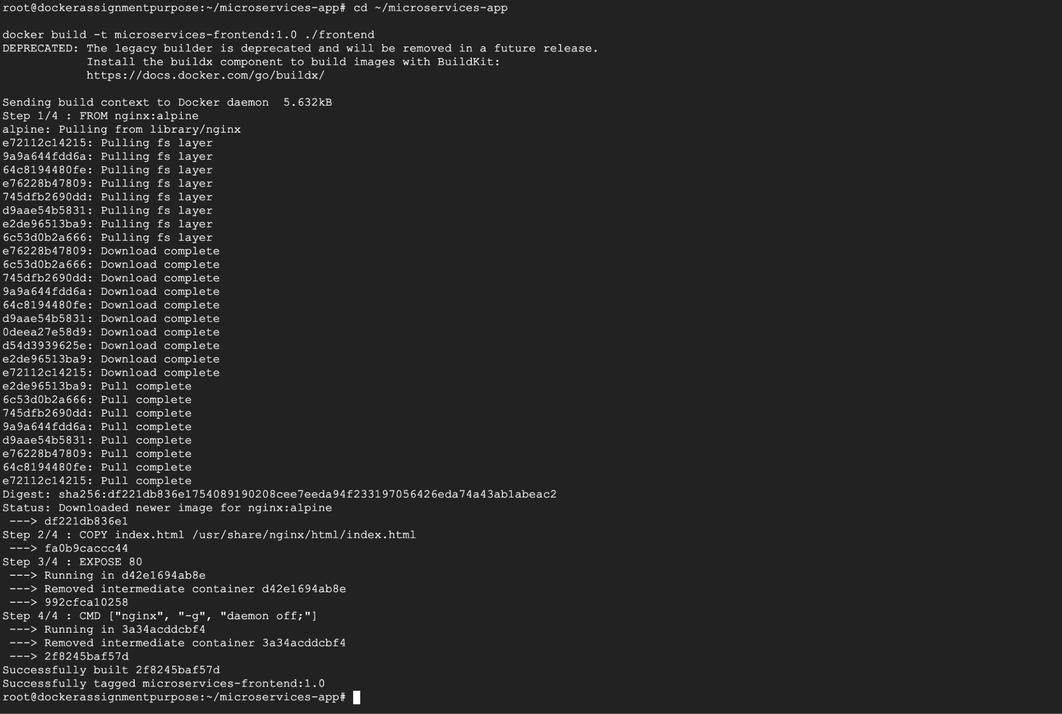

Build Backend Image : #docker build -t microservices-backend:1.0 ./backend

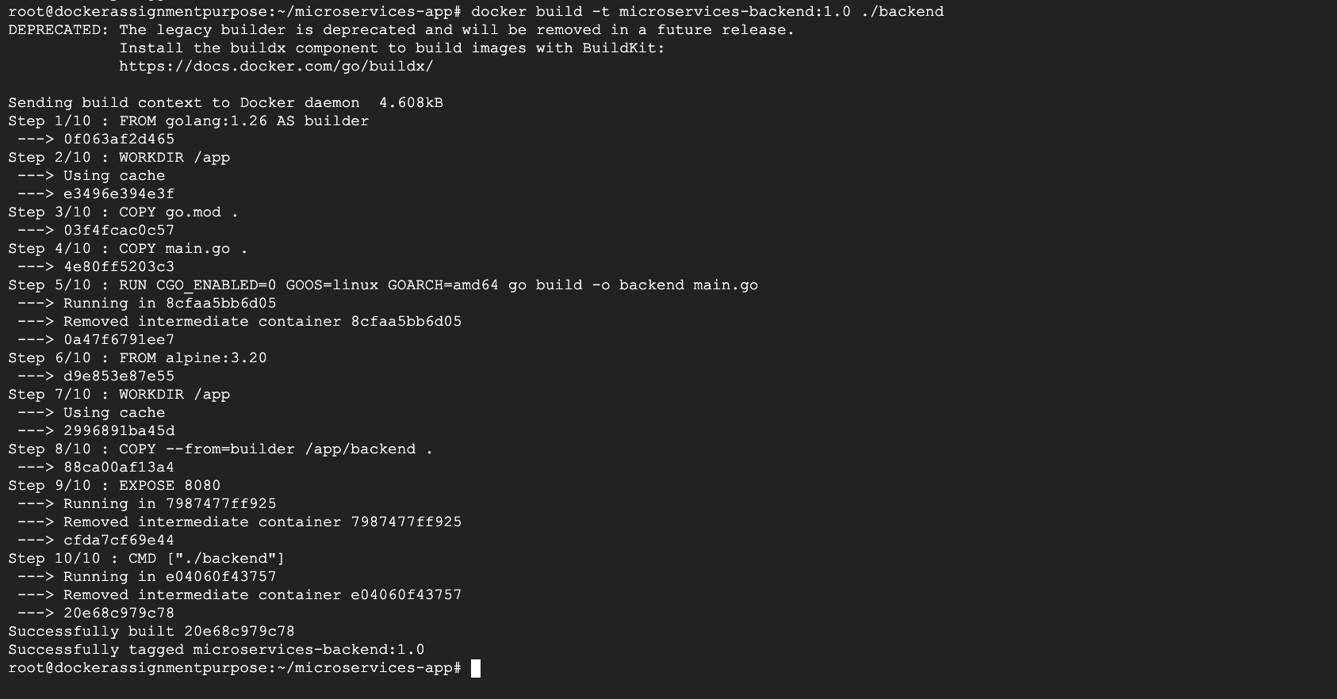
Build database image : docker build -t microservices-database:1.0 ./database

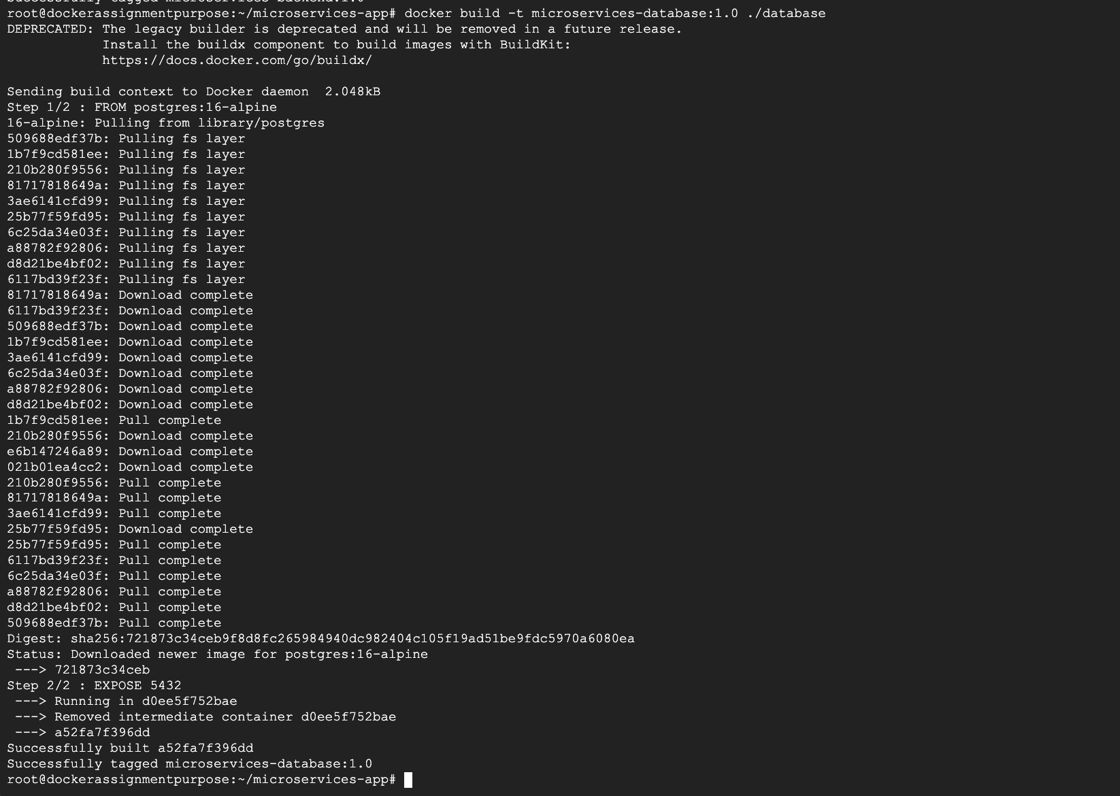

Check all three images :
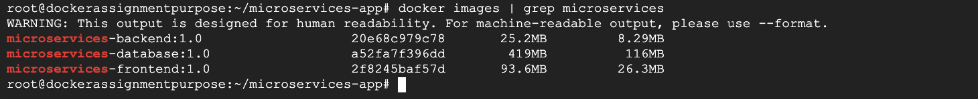

Task 4 - Tag Docker Images
Prepare Docker images for publishing by tagging them appropriately.
Tags should follow standard naming conventions for container registries.

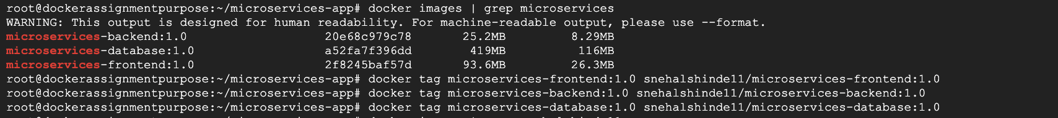

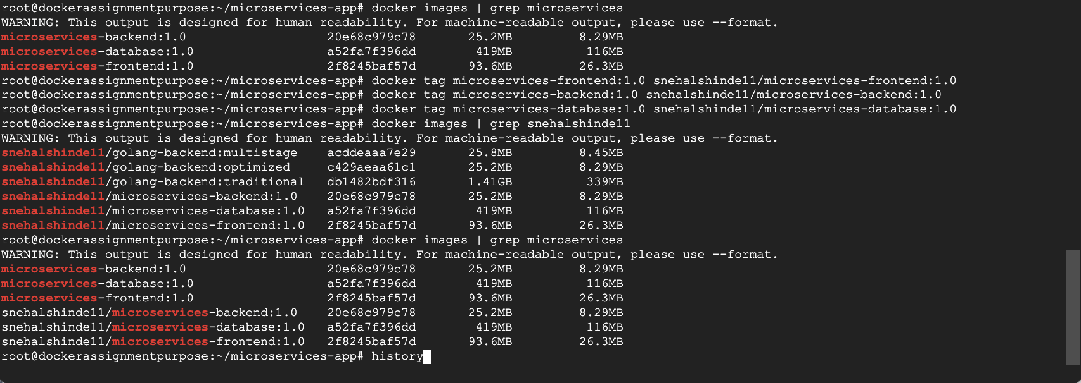

Task 5 - Push Images to Docker Hub
Publish the container images to Docker Hub so they can be publicly accessed and reused.
Verify that the images appear in the Docker Hub repository.
Run: docker login
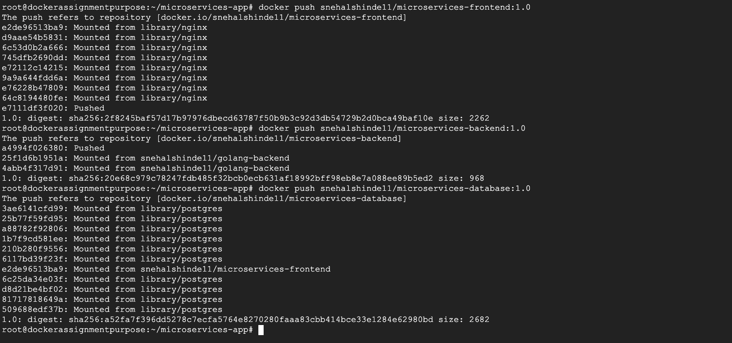

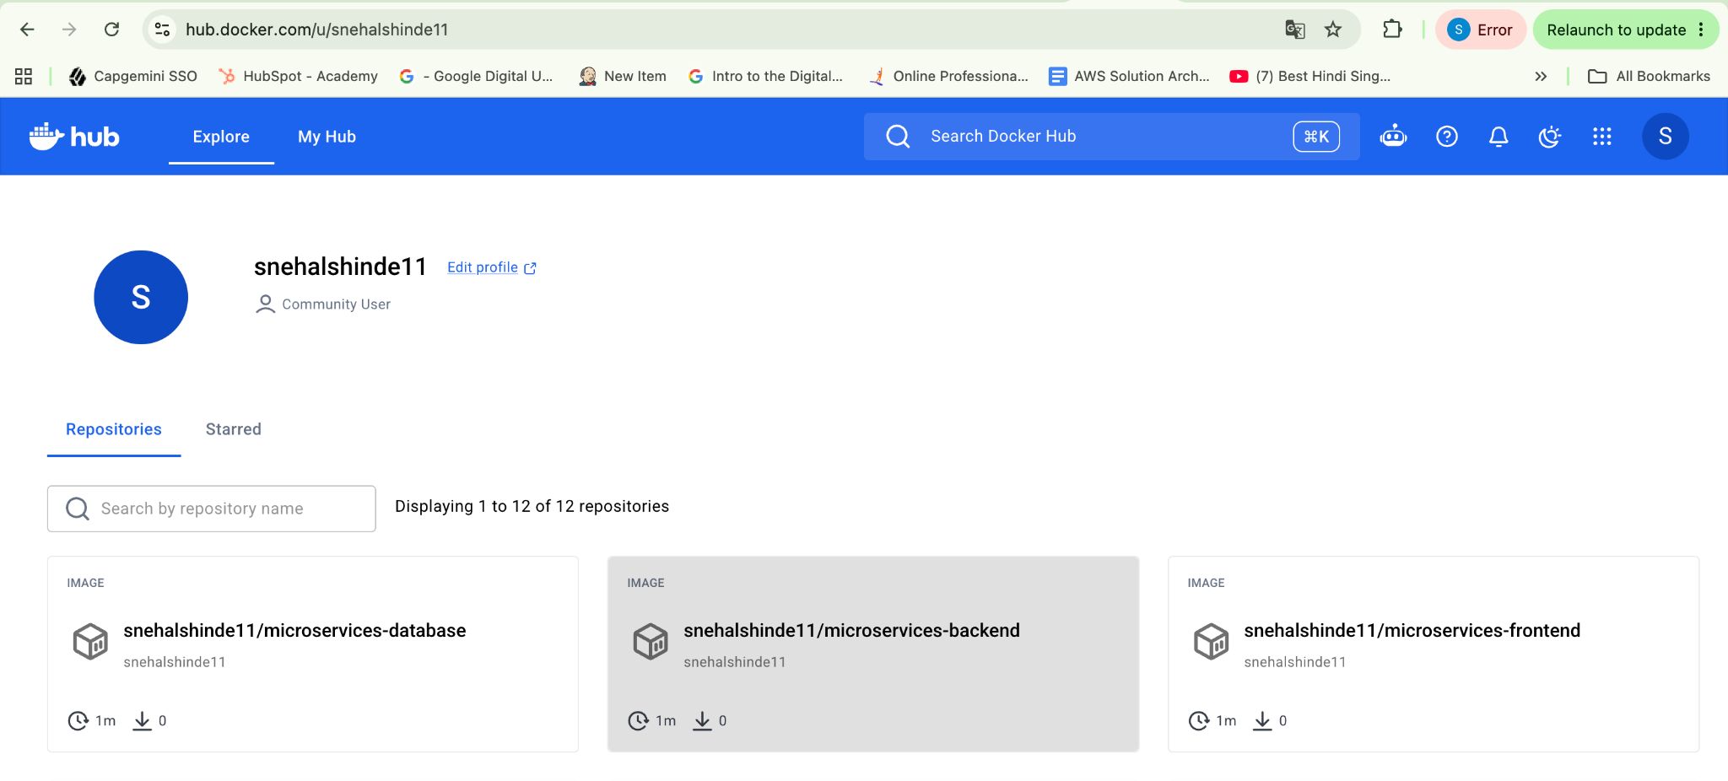

Task 6 - Push Images to AWS ECR
Create repositories in AWS Elastic Container Registry (ECR).
Push the microservice images to AWS ECR so they can be used in cloud deployments.

Install AWS CLI :
#apt update
#apt install -y curl unzip
#curl "https://awscli.amazonaws.com/awscli-exe-linux-x86_64.zip" -o "/tmp/awscliv2.zip"

Extract it: #unzip -q /tmp/awscliv2.zip -d /tmp
Install:/tmp/aws/install
Verify:aws --version

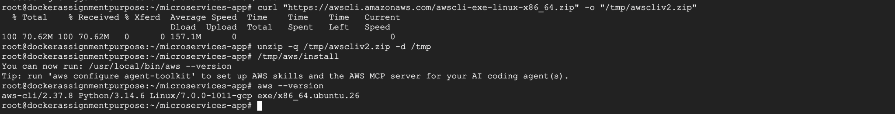
Check AWS credentials: aws sts get-caller-identity
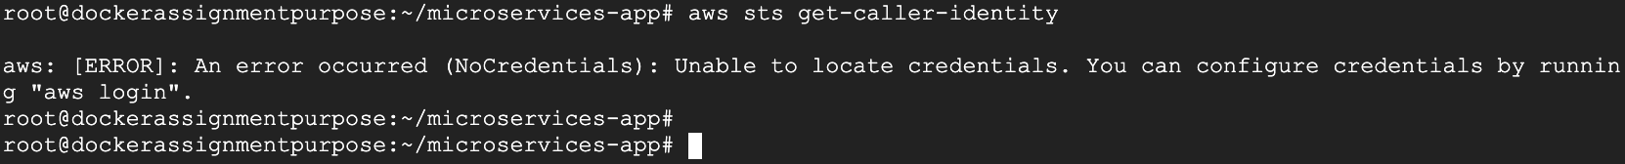

One important point first: don't create access keys for the AWS root account unless absolutely necessary. AWS recommends IAM users/roles or temporary credentials instead.

login in to the AWS Console and open:
Go to: IAM → Users
Step 2 — Create an IAM user →Click Create user.
For example, use: Username: ecr-user

For this assignment, the user needs permissions to authenticate with ECR and push images.
For a learning/lab environment, the simplest option is:
Permissions → Add permissions → Attach policies directly
You can attach: AmazonEC2ContainerRegistryPowerUser
This is broader than strictly necessary, but convenient for your ECR hands-on assignment.

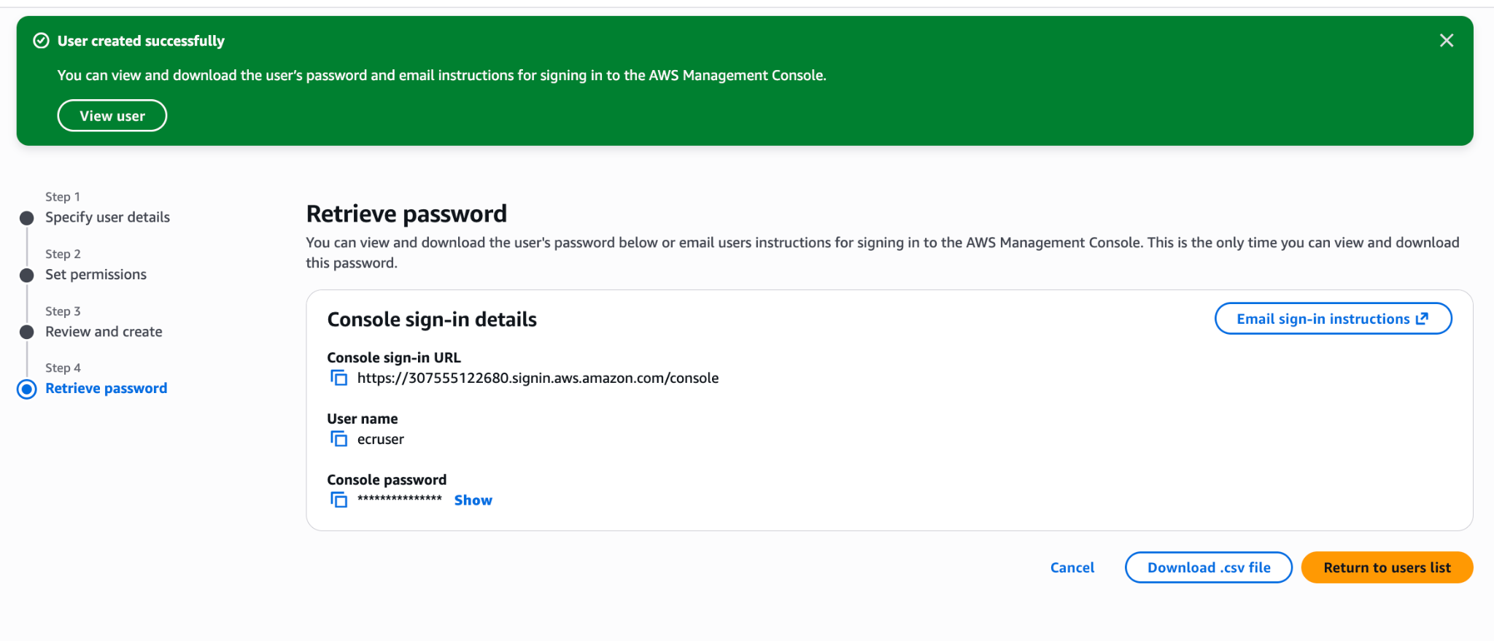

Step 4 — Create the access key→Open the newly created user:
Users → ecr-user → Security credentials
Find:Access keys → Create access key
AWS will ask for the use case.
Choose:
Command Line Interface (CLI)
Then continue and create the key. AWS's current console flow supports creating an access key specifically for CLI use.
Step 6 — Configure your Linux server
Back on your server:
aws configure
You'll enter:
AWS Access Key ID [None]: <your-access-key-id>
AWS Secret Access Key [None]: <your-secret-access-key>
Default region name [None]: us-east-1
Default output format [None]: json
The credentials will normally be stored under:
/root/.aws/
because you're currently logged in as root.
Verify the identity :
#aws sts get-caller-identity
#aws configure list

We'll create three ECR repositories:
#aws ecr create-repository --repository-name microservices-frontend --region us-east-1
Note down the repository url:
307555122680.dkr.ecr.us-east-1.amazonaws.com/microservices-frontend

#aws ecr create-repository --repository-name microservices-backend --region us-east-1
Note down the repository url:
307555122680.dkr.ecr.us-east-1.amazonaws.com/microservices-backend

#aws ecr create-repository --repository-name microservices-database --region us-east-1
Note down the repository url:
307555122680.dkr.ecr.us-east-1.amazonaws.com/microservices-database

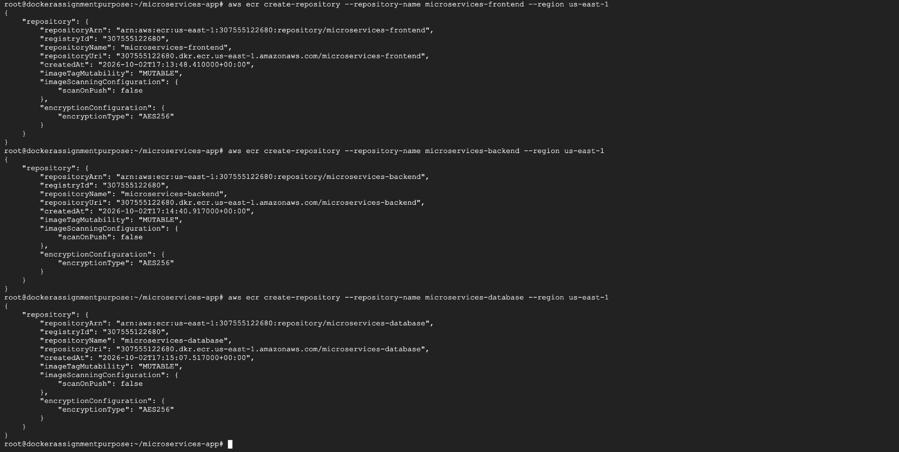

Verify all the repositories :
aws ecr describe-repositories \
--region us-east-1 \
--query 'repositories[].repositoryName' \
--output table

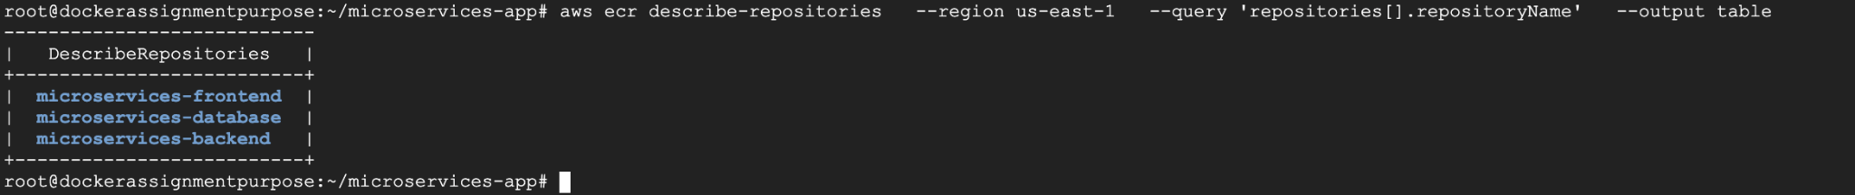

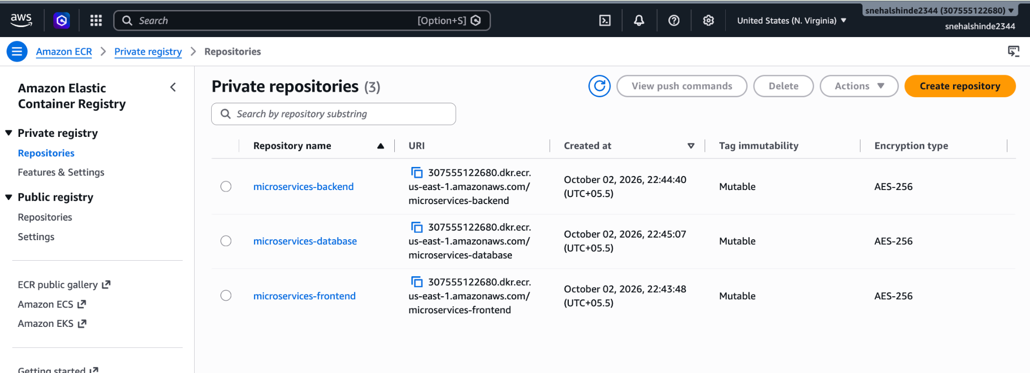

Login to ecr :
#aws ecr get-login-password --region us-east-1 | docker login --username AWS --password-stdin 307555122680.dkr.ecr.us-east-1.amazonaws.com
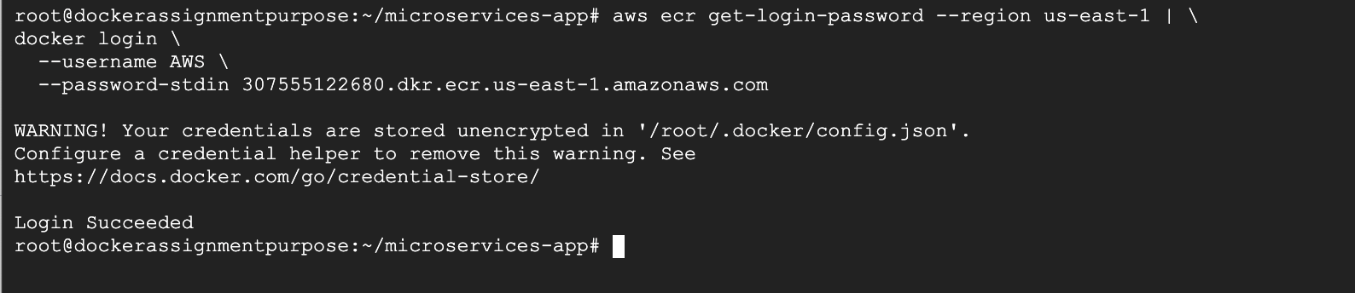

Tag the images :
# docker tag microservices-frontend:1.0 307555122680.dkr.ecr.us-east-1.amazonaws.com/microservices-frontend:1.0
#docker tag microservices-backend:1.0 307555122680.dkr.ecr.us-east-1.amazonaws.com/microservices-backend:1.0
#docker tag microservices-database:1.0 307555122680.dkr.ecr.us-east-1.amazonaws.com/microservices-database:1.0

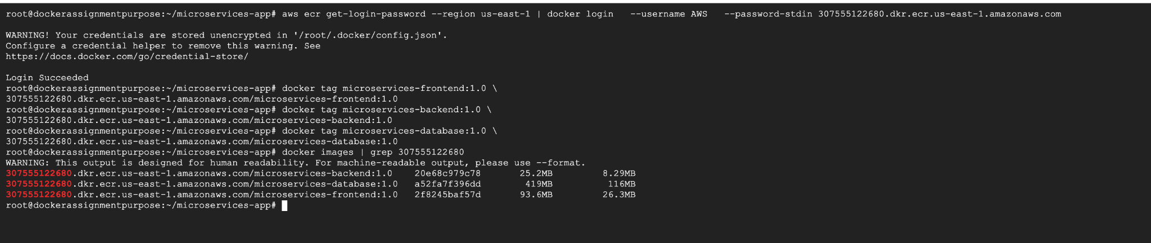

# docker push 307555122680.dkr.ecr.us-east-1.amazonaws.com/microservices-frontend:1.0
#docker push 307555122680.dkr.ecr.us-east-1.amazonaws.com/microservices-backend:1.0
#docker push 307555122680.dkr.ecr.us-east-1.amazonaws.com/microservices-database:1.0

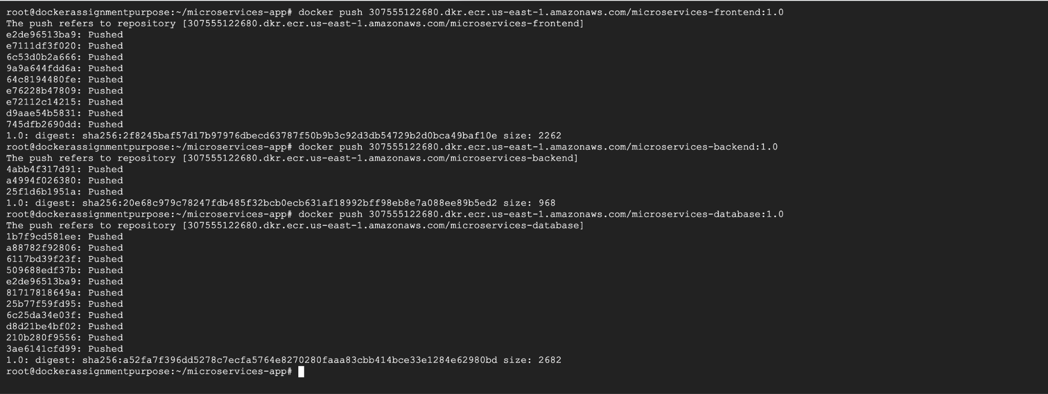

Task 7 - Verify Image Availability
Confirm that the images are successfully stored in both registries.
Check that other environments can pull and run these images.

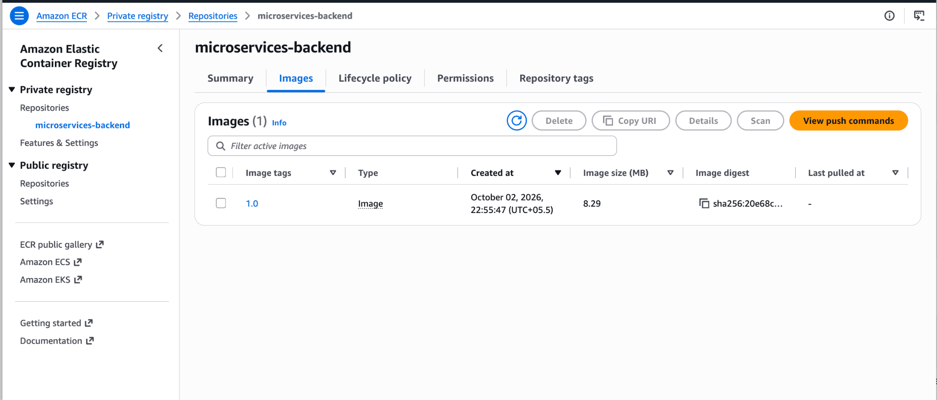
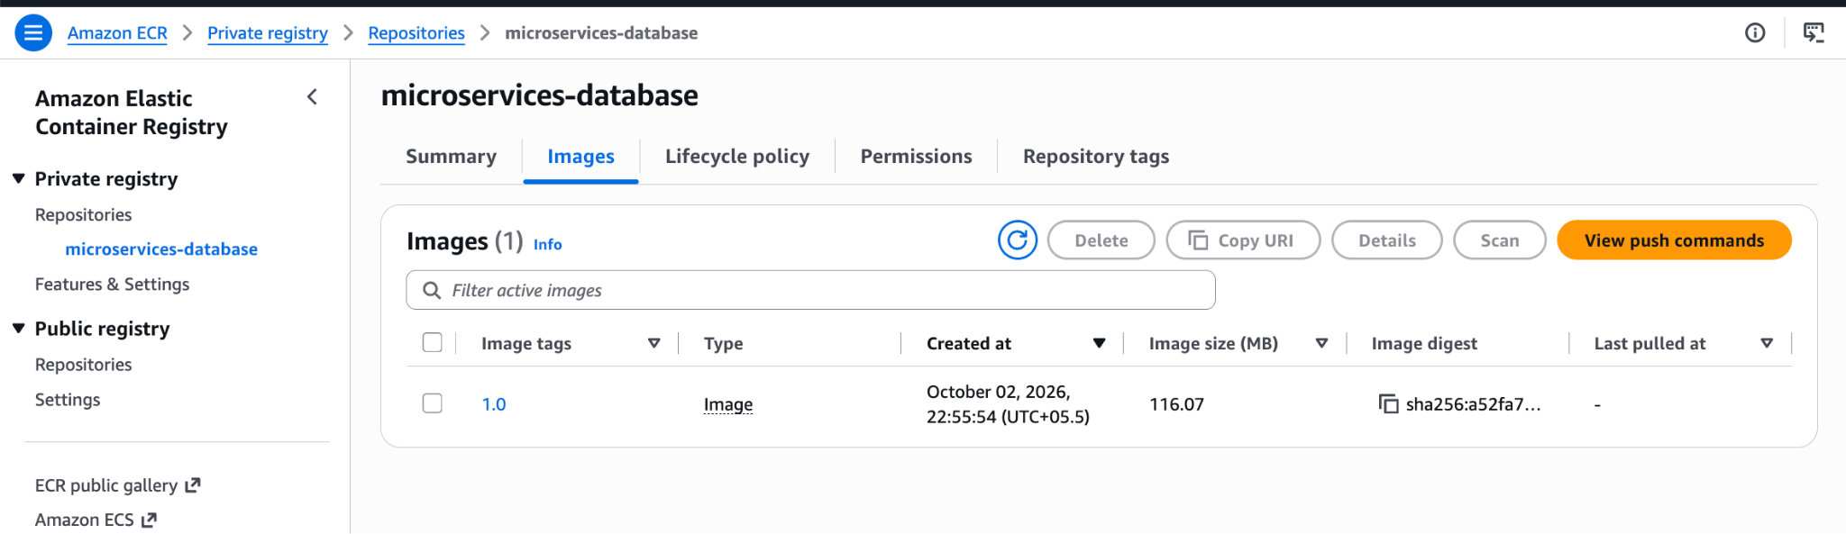
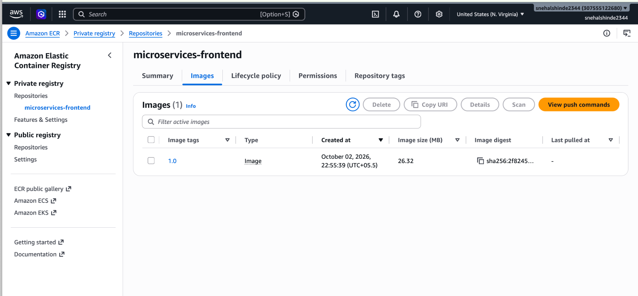

Run the Frontend
docker run -d \
--name test-frontend \
-p 8081:80 \
307555122680.dkr.ecr.us-east-1.amazonaws.com/microservices-frontend:1.0
Check:
docker ps
Test:
curl http://localhost:8081
You should see your Snehal Microservices Application HTML.
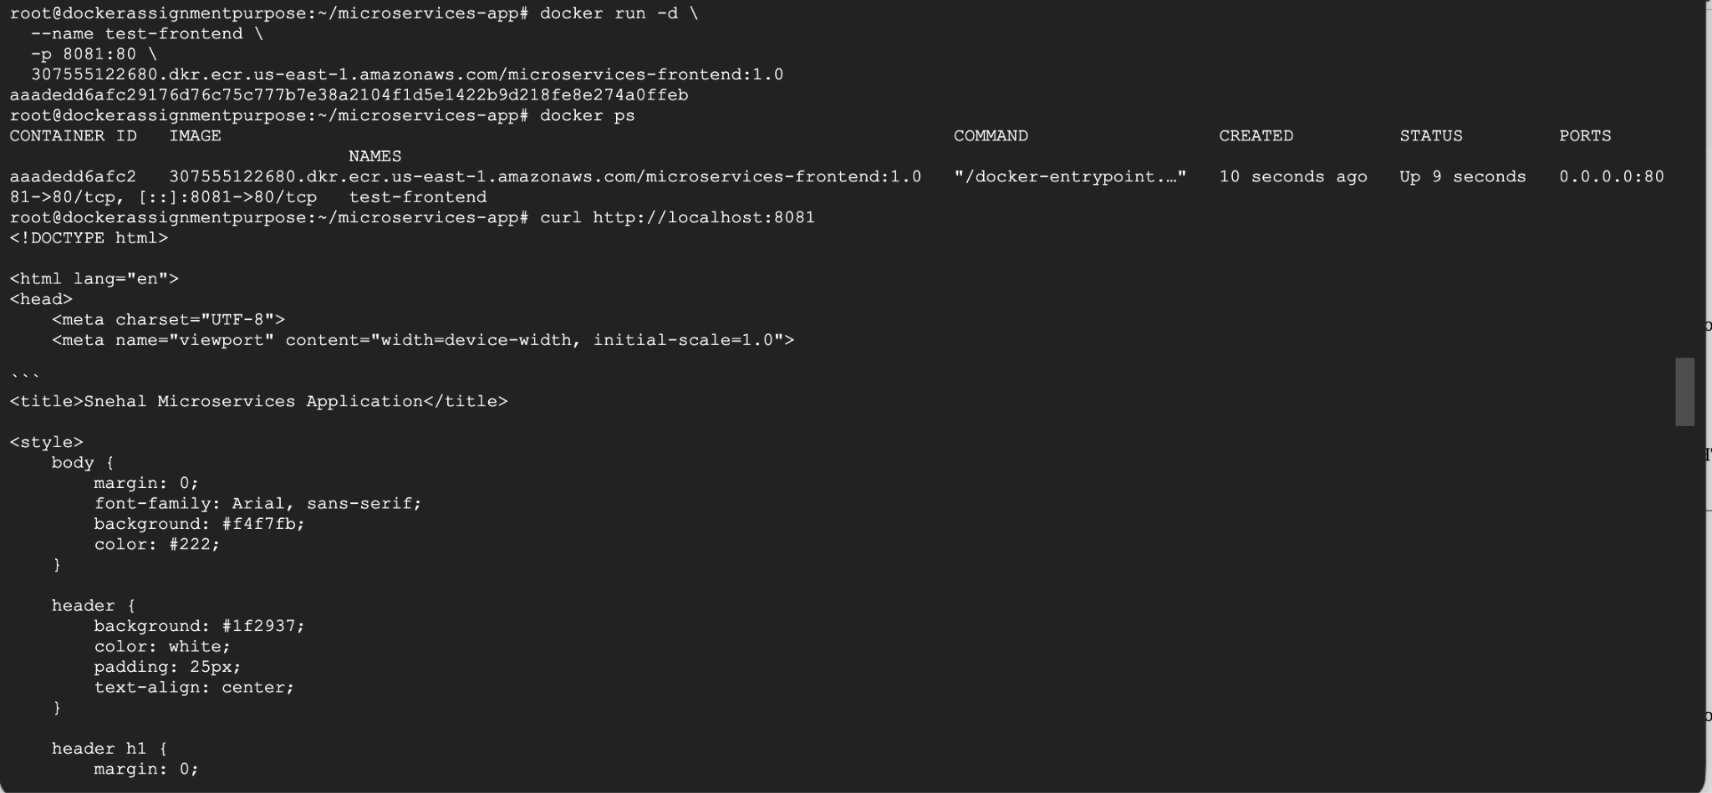

Run the Backend
docker run -d \
--name test-backend \
-p 8080:8080 \
307555122680.dkr.ecr.us-east-1.amazonaws.com/microservices-backend:1.0
Test:curl http://localhost:8080
Expected:Backend Service is running
This application is designed by Snehal for Demo Purpose
Health check:curl http://localhost:8080/health
Expected:Backend Service is healthy

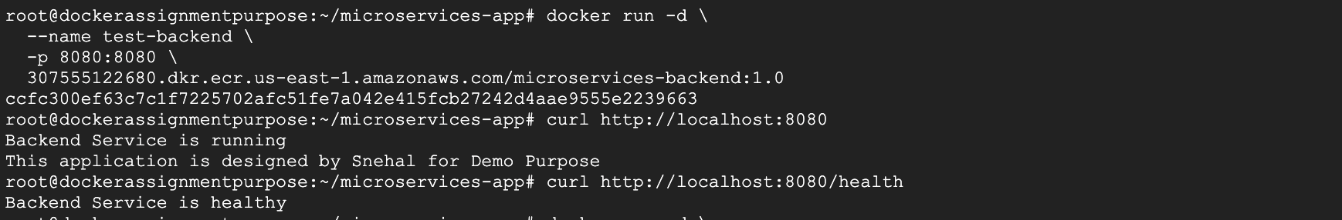

Run PostgreSQL with the secret
For the database, don't simply run the image without configuration, because we deliberately kept the credentials outside the Dockerfile.
Use the secret:
docker run -d \
--name test-database \
-p 5432:5432 \
--env POSTGRES_DB=microservices \
--env POSTGRES_USER=snehal \
--env POSTGRES_PASSWORD_FILE=/run/secrets/db_password \
--mount type=bind,source="$(pwd)/secrets/db_password.txt",target=/run/secrets/db_password,readonly \
307555122680.dkr.ecr.us-east-1.amazonaws.com/microservices-database:1.0
Check:docker ps
Then:docker logs test-database
Look for:database system is ready to accept connections

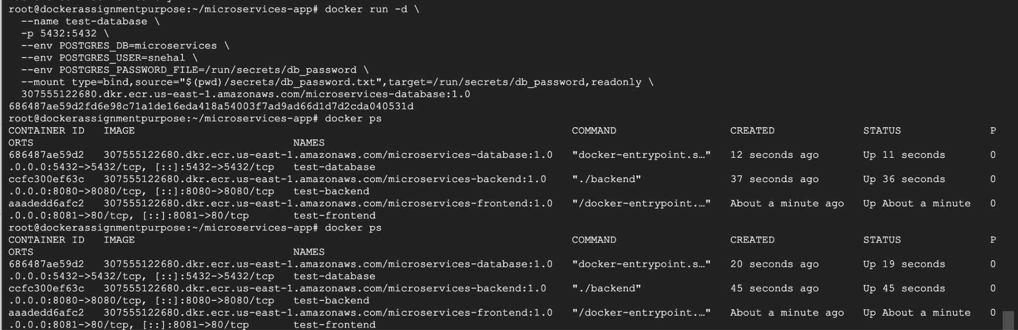
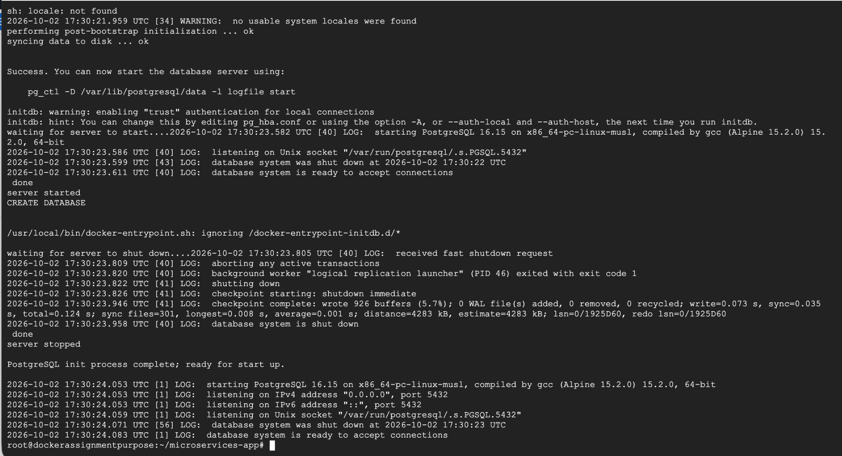

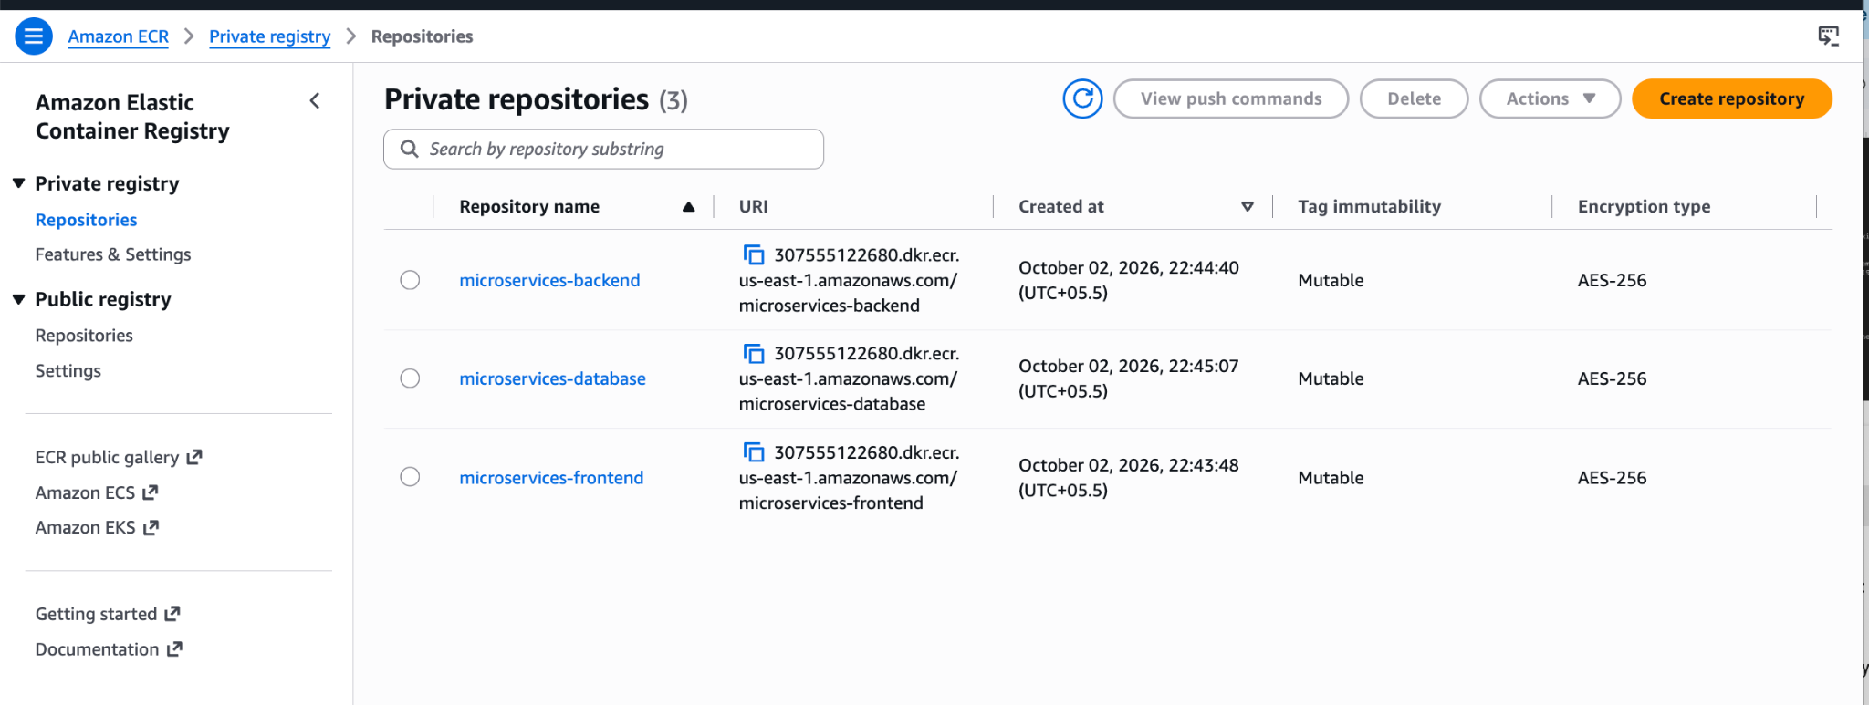

Beyond the Basics - Elevate Exercise
Enhance the project by implementing:
Docker Compose deployment :

Make Sure you have docker compose installed :
#cd ~/microservices-app
#docker compose config
#docker compose up -d
Before executing this make sure to delete all other containers which are using same ports :
#docker rm -f test-frontend test-backend test-database
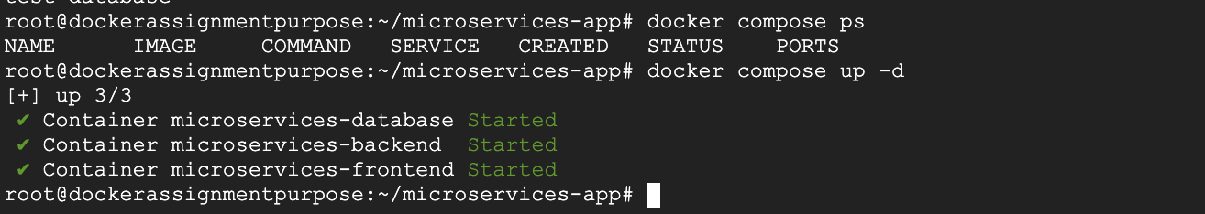
Use Docker Compose to run the frontend, backend, and database services together.

Step 3 — Test the services
Frontend:
curl http://localhost:8081
Backend:
curl http://localhost:8080
Health:
curl http://localhost:8080/health
Database:
docker compose logs database
Look for:
database system is ready to accept connections

Environment variable configuration.
docker compose exec backend env | grep -E 'APP_ENV|PORT|DB_HOST|DB_PORT|DB_NAME|DB_USER'

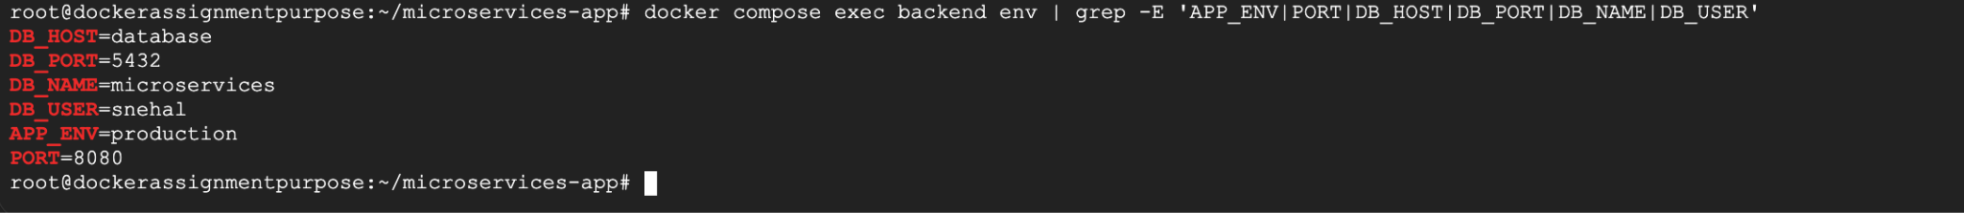

Configure application settings using environment variables inside containers.

1. Environment variable configuration
Your docker-compose.yml already passes configuration into the containers.

Verify backend variables
Run: docker compose exec backend env | grep -E 'APP_ENV|PORT|DB_HOST|DB_PORT|DB_NAME|DB_USER'
Expected:
APP_ENV=production
PORT=8080
DB_HOST=database
DB_PORT=5432
DB_NAME=microservices
DB_USER=snehal

Verify database variables
Run: docker compose exec database env | grep -E 'POSTGRES_DB|POSTGRES_USER|POSTGRES_PASSWORD_FILE'
Expected:
POSTGRES_DB=microservices
POSTGRES_USER=snehal
POSTGRES_PASSWORD_FILE=/run/secrets/db_password
Notice that we do not see the actual password. That's intentional. The password is provided through:
secrets/db_password.txt
↓
Docker secret
↓
/run/secrets/db_password
You can also verify the secret exists inside the database container:
docker compose exec database ls -l /run/secrets/db_password

-Let's make the backend actually consume the environment variables, then rebuild the backend image and update Compose.

Step 1 — Create main-env.go
Step 2 — Create Dockerfile.env
Step 3 — Build the new image
docker build \
-f backend/Dockerfile.env \
-t microservices-backend:v2 \
./backend

then
#docker images | grep microservices-backend
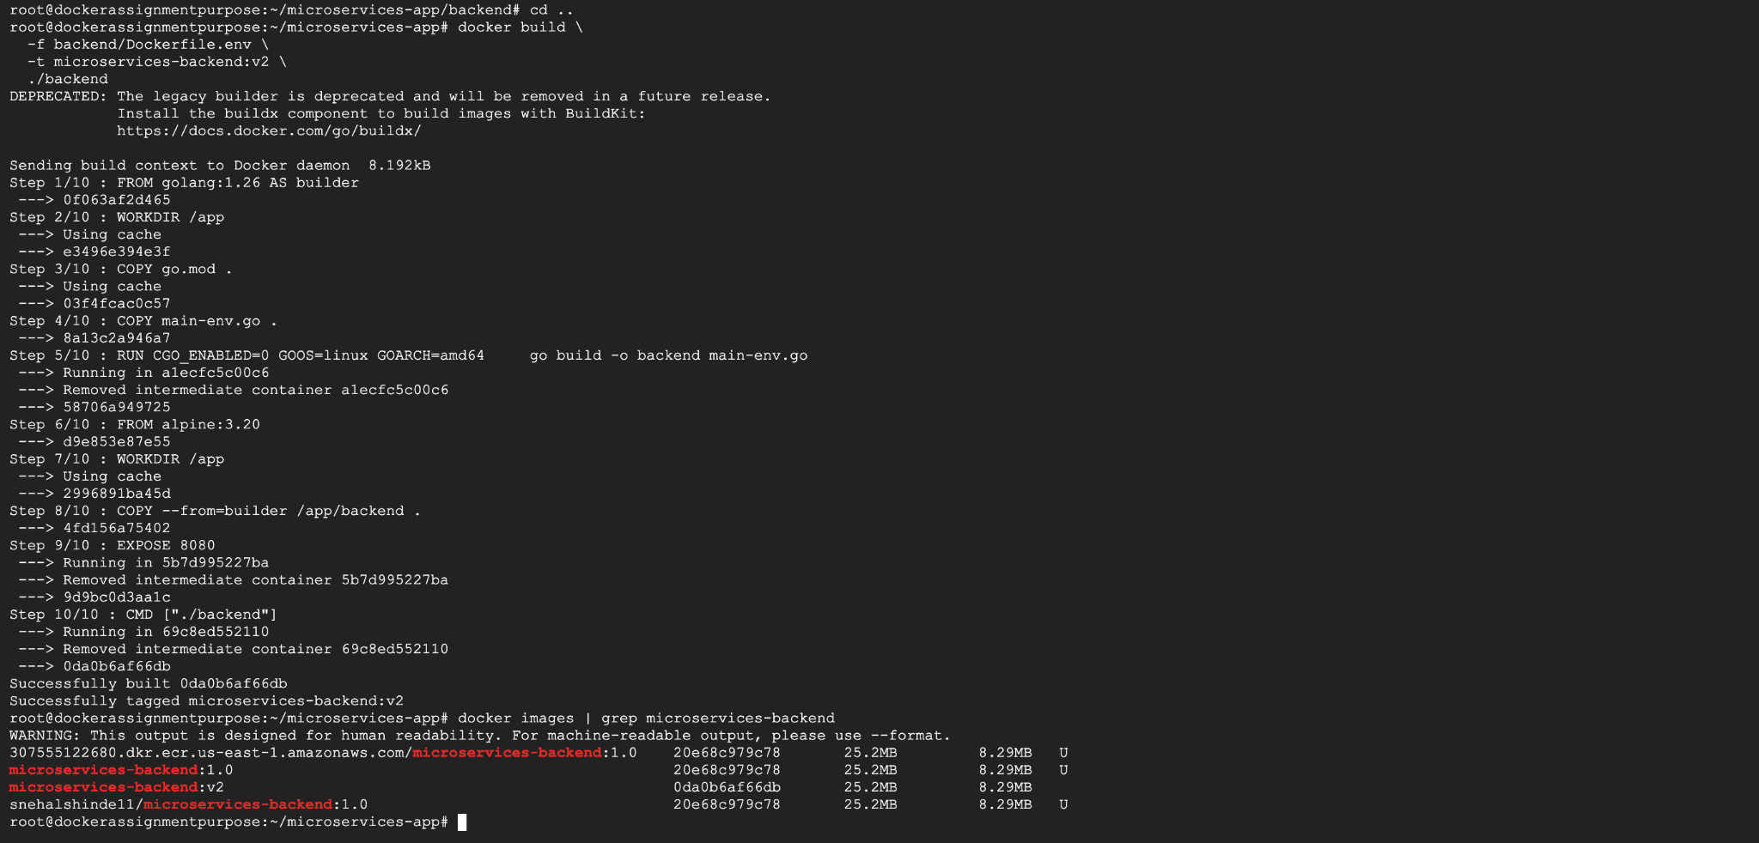

Step 4 — Test v2 independently
Before changing Compose, let's test the new image directly.
#docker run -d --name backend-v2-test -p 8082:8080 -e APP_NAME="Snehal Microservices Backend V2" -e APP_ENV="production" -e PORT="8080" -e DB_HOST="database" -e DB_PORT="5432" -e DB_NAME="microservices" -e DB_USER="snehal" microservices-backend:v2

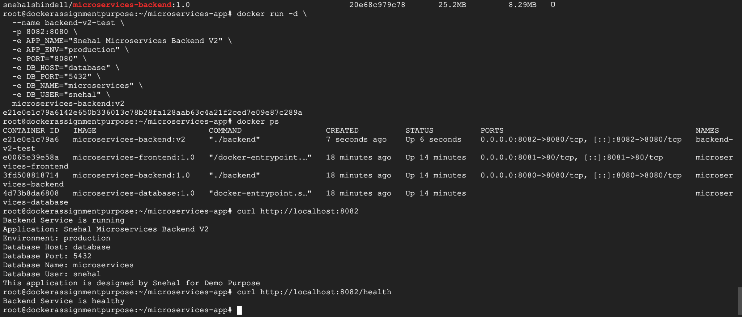

Now lets docker-compose-v2.yml

IMP : Why different ports?
Your original Compose stack is already running:
Frontend → 8081
Backend → 8080
Database → 5432
So the v2 stack needs different host ports:
Frontend v2 → 8083
Backend v2 → 8084
Database v2 → 5434
Inside the Compose network, the services still communicate using:
backend:8080
database:5432
That's important: container ports don't change just because host ports change.
Validate it #docker compose -f docker-compose-v2.yml config
If there are no errors: #docker compose -f docker-compose-v2.yml up -d
Then: docker compose -f docker-compose-v2.yml ps
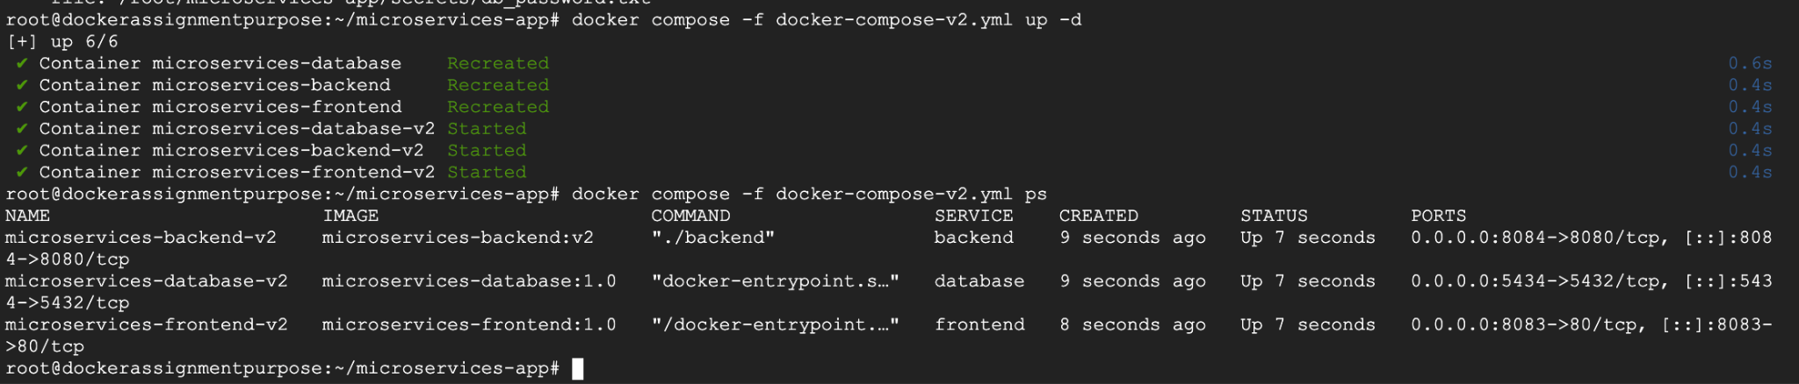
Test the v2 backend:
curl http://localhost:8084
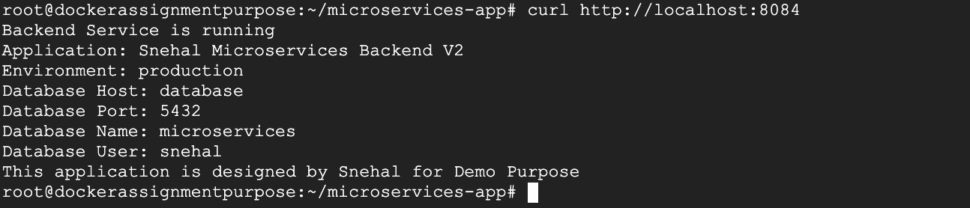

Versioned image tagging
First, tag your local v2 image: docker tag microservices-backend:v2 \
snehalshinde11/microservices-backend:v2
Then push it:
docker push snehalshinde11/microservices-backend:v2
Verify: docker images | grep microservices-backend
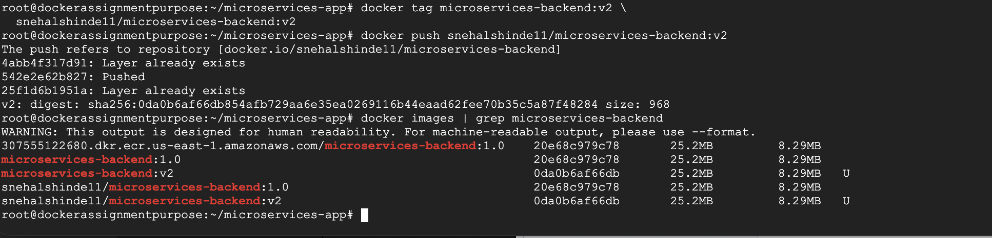
Tag images using version tags such as v1, v2, or latest to simulate production release management.

